Logo



Menu reorder:
- Post a Case
- Join as Advocate
- Law College
- Sawal Jawab
- Law Library

Login/Register

Login / Register buttons colors should always be different even on mouse hover effect (Add a hover effect that subtly adjusts the gradient by making the button’s background a bit lighter or darker).

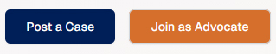
Try keeping all buttons distinctive using logo colors.

Footer



Use the background colour code [00377b]
Underline colour code [001944]
Headings: bold, white colour
All text: white colour

Company (Column 1)
- About Us
- Media Coverage
- Contact Us
- User Agreement
- Privacy Policy

Client Area (Column 2)
- Register
- Login
- FAQ's
- How It Works

Advocate Area (Column 3)
- Register
- Login
- FAQ's
- How It Works

Law School (Column 4a)
- Search Colleges
- Search a Sawaal
- Ask a Sawaal

Blogs (Column 4b)
Post a Blog

Law Library (Column 5)
- Legal Tips
- Agreements
- Area of Law
- Indian Bare Acts
- Rules
- Judgments
- Legal Forms
- Glossary

Advertise (Column 6a)
- Get in Touch

Social (Column 6b)
- Facebook
- X (Twitter)
- LinkedIn

Login / Register Screen
Keep the Login and Register pages separate.
- https://advocatekhoj-frontend.vercel.app/register
- https://advocatekhoj-frontend.vercel.app/login

Remove the mouse hover effect as they are merging.

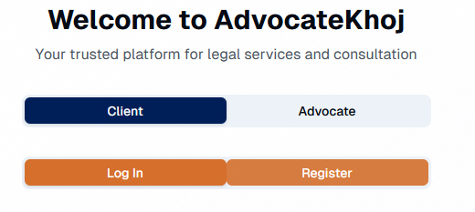

Client Area

Why Choose AdvocateKhoj?
Transparent Reviews

Post Your Legal Case
Location: From a Selection List [State], [City/Town]

Once inside the dashboard the Login/ Register from the header should not be visible.

I prefer the advertise section in the left panel of client dashboard to be masked unless they are logged as an advertiser.

Instead include “Post New Case” in the left panel.

Advocate Area

Office Phone > Mobile (in which case STD code is not required)

Note: Once your application is submitted, the name cannot be changed or updated. Please ensure all details are correct.

Registration Process:
- Submit this form with your basic details
- Admin will verify and check for duplicate records
- You'll receive username and password via email
- Login and complete your full profile (contact, practice areas, BAR affiliations)
- Admin reviews and approves your profile within 15 days

Unable to go to Step 2 of 2

Profile Management

- Always place the back button on the right corner.
- Mask Review option.
- Location: [State], [City]
- Bar Council Number – not required to display as we are collecting it during the registration process for internal validation purpose. I don’t want the advocate to modify it later at any cost.
- Practice Areas: We have numerous Practice Categories and Sub-categories (Practice Areas). Check existing database.
- Education: Use existing fields in the current database. Display Title: Law School/College/University/High School/Other School. Also we have provided a text box to input short details in the current database.
- Clients
- Publications
- Employment
- Affiliations / Membership

Please check the fields in the current database. Although I like to include “Professional Experience”, what about the existing members as this is a new field?

Available Cases

All Urgency can be put into more filters. Filtering by [State] and [City/Town, All] is more important. Also filtering by [Practice Category] and [Practice Areas, All].

Remove amount display: ₹25,000 - ₹50,000

Contact Us
Use Google reCAPTCHA
Phone number - don’t display
Email: customer_service@advocatekhoj.in
For urgent matters, please call us directly during business hours

Advertisement
The top banners and footer banner should be live on all pages including the client and advocate dashboard.

In the existing AdvocateKhoj, both client and advocate can login to the advertiser module and it’s a separate module altogether. Prefer to decouple it from client/advocate area.

